🧪 ⚠️ LAB: Exit Codes & Error Handling in Shell Scripting
🎯 Goal
You will learn:
- What exit codes are
- How to check success/failure
- How to handle errors in scripts
👉 This is used in automation, CI/CD, monitoring

🧠 Step 1: What is Exit Code?
Every command returns a status:
echo $?
👉 Output:
- 0 → Success ✅
- Non-zero (1,2…) → Failure ❌

🔍 Try this:
id="z61cx2"
ls
echo $?
👉 Should show 0
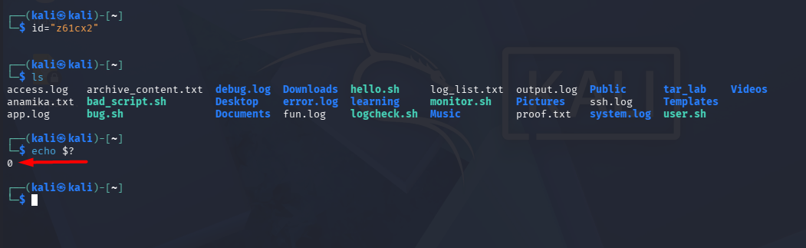
Now try:
id="a0y4c9"
ls wrongfile
echo $?
👉 Output:
2 ❌ (error)
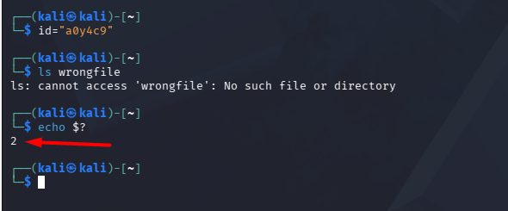

⚙️ Step 2: Create basic script
nano check.sh

✍️ Script:
id="n1xczv"
#!/bin/bash
echo "Checking file..."
ls test.txt
if [ $? -eq 0 ]; then
echo "✅ File exists"
else
echo "❌ File not found"
fi
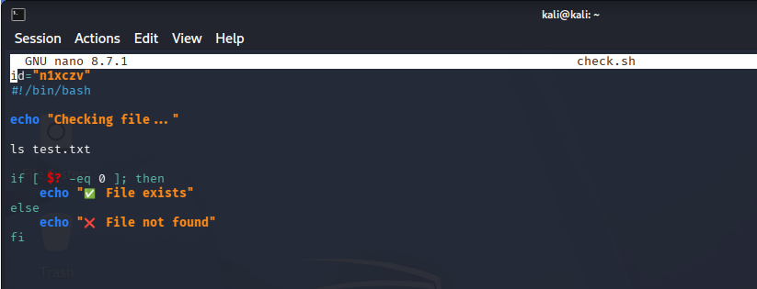

▶️ Step 3: Run it
chmod +x check.sh
./check.sh
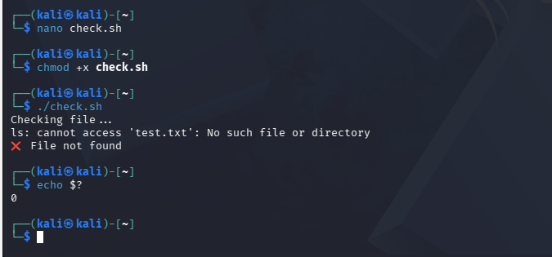

💥 Step 4: Better method (cleaner)
Instead of $?, use:
id="npv2j1"
#!/bin/bash
if ls test.txt
then
echo "✅ File exists"
else
echo "❌ File not found"
fi
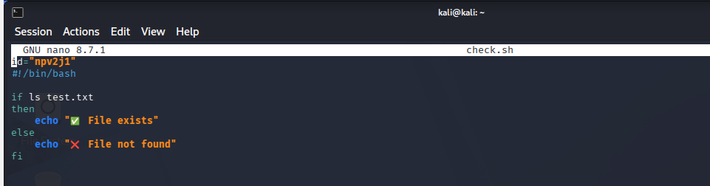
👉 More readable ⭐

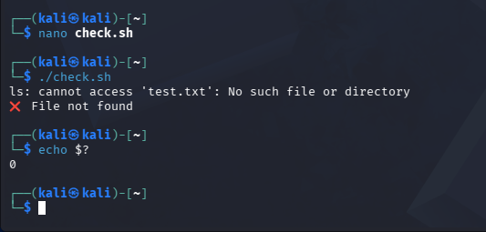

🚨 Step 5: Exit script manually
id="y6zw9k"
#!/bin/bash
echo "Starting script..."
if [ ! -f app.log ]; then
echo "❌ Log file missing!"
exit 1
fi
echo "Processing logs..."
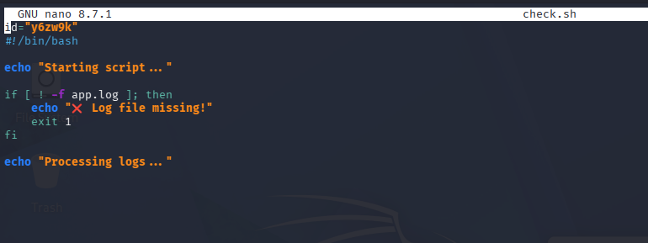
We see that the exit code is 0 as app.log exist in my system.
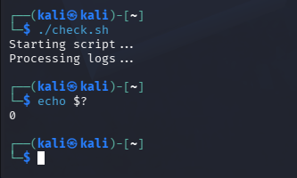

I modified the check.sh and changed the file name to ana.log which doesn’t exist in my system and hence it immediately executed exit 1
👉 exit 1 stops script immediately


🔥 Step 6: Combine with log monitoring
id="c1tq0z"
#!/bin/bash
LOG="app.log"
if [ ! -f "$LOG" ]; then
echo "❌ File not found"
exit 1
fi
errors=$(grep -c "ERROR" $LOG)
if [ $errors -gt 0 ]; then
echo "🚨 Errors found: $errors"
exit 2
else
echo "✅ No errors"
exit 0
fi
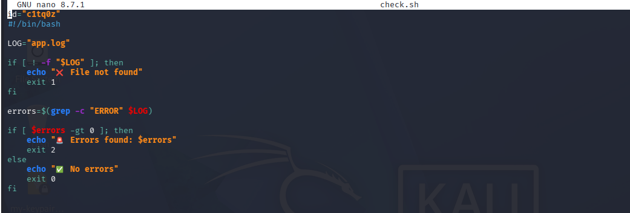

🧠 Step 7: Capture script exit code
Run script:
./script.sh
echo $?
👉 Output:
- 0 → healthy
- 1 → file missing
- 2 → errors found


🎯 Real-world usage
- CI/CD pipelines
- Monitoring systems
- Automation scripts
💡 Key takeaway
👉 Exit codes = decision-making in automation

🚀 Mini Challenge
👉 Modify script to:
- Check WARNING also
- Return different exit codes
